clear, clc, close all

% Work with values around center c  
c = pi/2;  
x = -4 : .1 : 6;  
y = cos(x);

% Plot the goal  
plot(x, y, 'g', 'Linewidth', 3)  
title('Study of Taylor series')  
xlabel('x')  
ylabel('cos(x) with different number of terms')  
axis([-4 6 -3 3])  
grid on  
hold on

% Consider 4 terms in the series  
smp = taylor_cosine(c, x, 4);  
plot(x, smp, 'ro')

% Consider 6 terms  
smp = taylor_cosine(c, x, 6);  
plot(x, smp, 'b-.')

% Consider 10 terms  
smp = taylor_cosine(c, x, 10);  
plot(x, smp, 'k', 'linewidth', 3)

% Label the calculated lines  
legend('cos(x)', '4-term series', ...  
       '6 terms', '10 terms')

The results are:

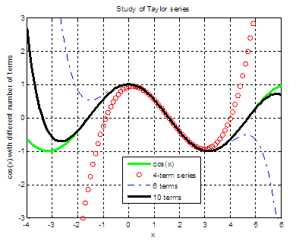

We see that all of the Taylor expansions work well when we are close to pi/2 (x approx. 1.57). More terms approximate better a larger portion of the cosine curve.